**About Dataset**

**Introduction**

Electric vehicles, marked by early innovations, periods of decline, and a remarkable resurgence in recent decades. From the pioneering efforts of the 19th century to the transformative breakthroughs of the 21st century, EVs have continually evolved, driven by technological advancements, environmental considerations, and shifting market dynamics.

I also examine the various types of electric vehicles currently available, including Battery Electric Vehicles (BEVs), Fuel Cell Electric Vehicles (FCEVs), and Plug-in Hybrid Electric Vehicles (PHEVs). Each of these powertrains offers unique advantages and challenges, reflecting the diverse needs and preferences of today’s drivers.

Through data visualisations and analysis, I present a snapshot of global EV trends, showcasing the growth of EV sales and the distribution of different powertrain types across regions. As we look towards the future, the Global EV Outlook underscores the potential of electric mobility to reshape the transportation landscape and drive us toward a more sustainable and innovative future.

**History of Electric Vehicles**

The history of electric vehicles (EVs) is rich and varied, spanning well over a century of innovation, decline, and resurgence. Let's look at the evolution of EVs, focusing on their early history, the oil crisis of the 1970s, and notable vehicles like the Sinclair C5.

**Early History of Electric Vehicles**

**Late 19th Century - Early 20th Century:**

* **Origins**: The concept of electric vehicles dates back to the early 19th century. The first practical electric car was built by Scottish inventor Robert Anderson around 1832-1839. It was a crude electric carriage powered by non-rechargeable batteries.
* **Early 20th Century Market Share**:
  + By the early 1900s, electric vehicles, gasoline-powered cars, and steam cars each held significant shares of the market. In fact, during the turn of the 20th century, electric vehicles were quite popular. They were considered quieter and easier to drive compared to the noisy and cumbersome gasoline cars of the time.
  + In 1900, electric vehicles had about a third of the automotive market share. This was a time when EVs were favoured by many urban drivers due to their reliability and lack of the manual hand-cranking that gasoline cars required.
  + Notable early EVs included the Detroit Electric Car Company models, which were popular with wealthy individuals and celebrities like Thomas Edison and Henry Ford.
* **Decline**:
  + The decline of electric vehicles began with the advent of more affordable and practical gasoline-powered vehicles. Innovations like the electric starter, improved road infrastructure, and the mass production techniques of Henry Ford’s Model T made gasoline cars more accessible and practical.
  + By the 1920s, the market for electric vehicles had dwindled as internal combustion engines and the infrastructure to support them, such as gas stations, became more widespread.

**The 1970s Oil Crisis and the Revival of Interest in EVs**

* **Oil Crisis**:
  + The 1970s oil crisis, triggered by the 1973 Arab Oil Embargo and the 1979 energy crisis, brought renewed interest in alternative energy sources, including electric vehicles. Rising oil prices and concerns about energy security highlighted the need for less oil-dependent transportation solutions.
  + During this period, there was a push for the development of electric vehicles as a means to reduce reliance on fossil fuels and mitigate the impact of future oil shortages.
* **Early 1970s Efforts**:
  + Various automotive manufacturers and research institutions experimented with electric vehicles during this time. Many of these early attempts were limited by the technology of the era, including the limitations of battery performance and range.

**Notable Vehicles and Innovations**

**Sinclair C5 (1985)**:

* **Overview**:
  + The Sinclair C5, designed by Sir Clive Sinclair, was an electric vehicle launched in 1985. It was a small, three-wheeled electric vehicle intended for short trips and urban commuting.
  + The C5 had a top speed of about 15 miles per hour and a range of around 20-30 miles on a single charge. It was designed to be affordable and practical for daily use.
* **Reception**:
  + Despite its innovative concept, the Sinclair C5 faced criticism for its limited speed, range, and lack of weather protection. It was also considered unsafe by some due to its low profile and exposure to road hazards.
  + The vehicle was not a commercial success and was discontinued after a short production run. However, it remains an important historical footnote in the evolution of electric vehicles.

**Other Notable Early EVs**

* **General Motors EV1 (1996-1999)**:
  + The GM EV1 was one of the first mass-produced electric cars of the modern era. Launched in the late 1990s, it was notable for its advanced technology and the fact that it was designed specifically as an electric vehicle.
  + The EV1 was praised for its performance and efficiency but was limited in production and availability. Due to a combination of high costs and the lack of support infrastructure, GM ultimately decided to discontinue the EV1 and retrieve most of the vehicles from customers.

**Modern Resurgence**

* **21st Century**:
  + The early 2000s saw a resurgence in interest in electric vehicles, driven by technological advancements in battery technology, increasing environmental concerns, and governmental incentives.
  + Tesla Motors, founded in 2003, played a significant role in popularising electric vehicles with its high-performance Tesla Roadster and later the Model S. Other major automotive manufacturers also entered the EV market, leading to a rapid expansion of available models and improvements in technology.
* **Recent Developments**:
  + Today, electric vehicles have become a significant segment of the automotive industry. Advances in battery technology, growing charging infrastructure, and stricter emissions regulations have contributed to their increasing market share.
  + The focus has shifted towards achieving longer ranges, faster charging, and integrating autonomous driving technology into electric vehicles.

**Summary**

The history of electric vehicles spans from early innovations in the 19th century to a significant resurgence in the 21st century. The market share of electric vehicles was notably high in the early 1900s but declined with the rise of gasoline-powered cars. The 1970s oil crisis sparked renewed interest in EVs, leading to various experimental models. Notable early electric vehicles, such as the Sinclair C5 and GM EV1, paved the way for the modern electric vehicle revolution. Today, electric vehicles are at the forefront of automotive technology, with continued advancements and growing adoption worldwide.

**Types of EVs**

The three main types of electric vehicle (EV) powertrains: Battery Electric Vehicles (BEVs), Fuel Cell Electric Vehicles (FCEVs), and Plug-in Hybrid Electric Vehicles (PHEVs). Each of these powertrains has distinct characteristics, advantages, and limitations.

**1. Battery Electric Vehicles (BEVs)**

**Definition**:

* BEVs are fully electric vehicles powered entirely by batteries. They do not use gasoline or diesel and rely solely on electric power.

**Key Features**:

* **Power Source**: BEVs are powered by rechargeable batteries that store electrical energy.
* **Range**: They typically offer a range of 100 to 400+ miles on a single charge, depending on the battery size and efficiency.
* **Charging**: BEVs are charged through electric vehicle supply equipment (EVSE) at home or public charging stations.
* **Emission**: BEVs produce zero exhaust/tailpipe emissions, making them environmentally friendly.
* **Maintenance**: They generally require less maintenance compared to internal combustion engine (ICE) vehicles since they have fewer moving parts.

**Examples**:

* Tesla Model 3, Nissan Leaf, Chevrolet Bolt EV

**Advantages**:

* Zero exhaust/tailpipe emissions, reducing environmental impact.
* Lower operating costs, including cheaper "fuel" (electricity) and lower maintenance.
* Generally offer high performance and smooth driving experience due to instant torque from electric motors.

**Limitations**:

* Limited driving range compared to some ICE vehicles, though this is improving with advances in battery technology.
* Charging infrastructure is still developing in some areas, which can lead to "range anxiety" for some drivers.

**2. Fuel Cell Electric Vehicles (FCEVs)**

**Definition**:

* FCEVs use hydrogen fuel cells to generate electricity on-board. The electricity powers the electric motor, and the only emission is water vapour.

**Key Features**:

* **Power Source**: FCEVs use hydrogen stored in tanks and a fuel cell stack to produce electricity.
* **Range**: They typically offer a range of 300 to 400+ miles on a full tank of hydrogen.
* **Refuelling**: Hydrogen can be refuelled at hydrogen stations, which are less common than EV charging stations.
* **Emission**: FCEVs emit only water vapour, making them environmentally friendly.
* **Maintenance**: Similar to BEVs, they have fewer moving parts compared to ICE vehicles.

**Examples**:

* Toyota Mirai, Hyundai Nexo, Honda Clarity Fuel Cell

**Advantages**:

* Fast refuelling times similar to conventional gasoline vehicles (around 3-5 minutes).
* Longer driving ranges compared to many BEVs.
* Zero exhaust/tailpipe emissions.

**Limitations**:

* Limited hydrogen refuelling infrastructure, which restricts their availability in many regions.
* Hydrogen production can be energy-intensive and environmentally impactful if not produced from renewable sources.
* Current costs of hydrogen fuel cells and infrastructure are relatively high.

**3. Plug-in Hybrid Electric Vehicles (PHEVs)**

**Definition**:

* PHEVs combine a traditional internal combustion engine with an electric motor and a rechargeable battery. They can operate in electric-only mode or use the combustion engine for extended range.

**Key Features**:

* **Power Source**: PHEVs have both an electric motor and a gasoline or diesel engine. The battery can be charged via an external source.
* **Range**: They offer a limited all-electric range (typically 20 to 50 miles) and can switch to hybrid mode for longer trips.
* **Charging**: The battery can be charged from a standard electrical outlet or charging station.
* **Emission**: When operating in electric-only mode, they produce zero emissions. In hybrid mode, they produce emissions similar to conventional vehicles.
* **Maintenance**: PHEVs require maintenance for both the electric and internal combustion systems.

**Examples**:

* Toyota Prius Prime, Mitsubishi Outlander PHEV, Ford Escape Plug-in Hybrid

**Advantages**:

* Flexibility of operating in electric-only mode for short trips and using the gasoline engine for longer journeys.
* Can reduce fuel consumption and emissions compared to conventional vehicles.
* More convenient refuelling compared to FCEVs, as gasoline stations are more widespread.

**Limitations**:

* Battery range may be limited compared to BEVs, leading to reliance on the combustion engine for longer trips.
* Typically higher upfront costs than conventional vehicles due to the additional complexity of the hybrid system.
* Still requires gasoline, so not completely free from fossil fuels.

**Summary**

* **BEVs**: Entirely electric with zero exhaust/tailpipe emissions, long-term cost benefits, but dependent on charging infrastructure and battery range.
* **FCEVs**: Use hydrogen to generate electricity with zero tailpipe emissions and quick refuelling, but face challenges with hydrogen infrastructure and production costs.
* **PHEVs**: Offer a blend of electric and traditional power with greater flexibility for longer trips, but still rely on fossil fuels and have limited electric-only range.

Each type of powertrain has its strengths and fits different use cases and user needs. The choice among them often depends on factors like driving habits, availability of refuelling or charging infrastructure, and environmental goals.

**Visualisation: IEA Global EV Data 2024.csv**

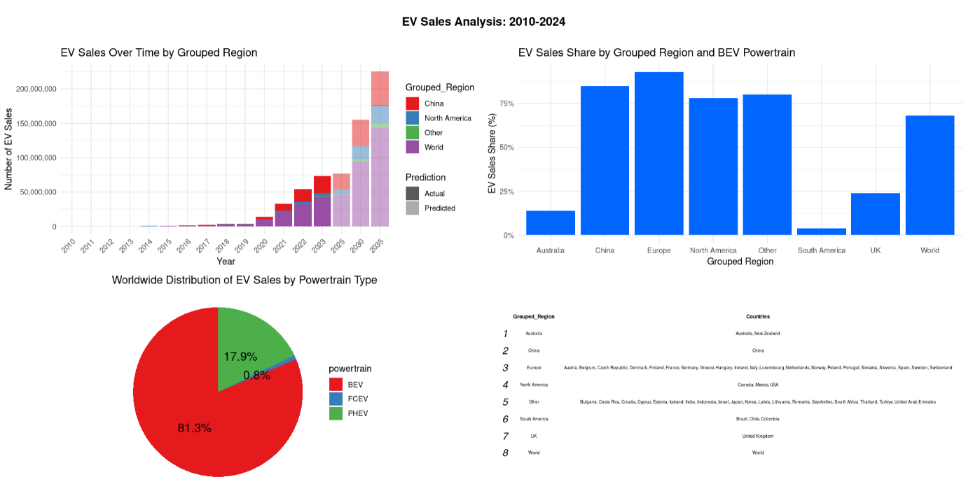

*BEVs are battery electric vehicles. PHEVs are plug-in hybrid electric vehicles. FCEVs are fuel cell electric vehicles. EVs refers to all electric vehicles (BEVs + PHEVs).*

**"EV Sales Over Time by Grouped Region":**

* This chart shows that EV sales have been increasing globally since 2010.
* China is the region that has bought the most electric vehicles, followed by North America.

**"EV Sales Share by Grouped Region and BEV Powertrain":**

* This chart shows that the majority of EVs sold globally in 2024 were battery electric vehicles (BEVs).
* China is again the region that has purchased the most BEVs, followed by North America.

**"Worldwide Distribution of EV Sales by Powertrain Type":**

* This chart shows that BEVs account for the largest share of EV sales globally, followed by plug-in hybrid electric vehicles (PHEVs) and fuel cell electric vehicles (FCEVs).

A Markdown document with the R code for the above multi-plot.

**So, to answer my own question: Historically, EVs have come and gone. Are they here to stay ?**

I firmly believe that electric vehicles (EVs) are here to stay, and I offer several reasons to support this assertion:

**Environmental Benefits**

**Reduced Emissions:** EVs produce zero exhaust/tailpipe emissions, contributing significantly to the reduction of air pollution and greenhouse gas emissions. This is crucial for addressing climate change and improving air quality.

**Technological Advancements**

**Battery Technology:** Continuous improvements in battery technology are increasing the range, reducing the charging time, and lowering the cost of EVs. Innovations such as solid-state batteries promise even greater advancements.

**Economic Factors**

**Lower Operating Costs:** EVs generally have lower operating and maintenance costs compared to internal combustion engine (ICE) vehicles. Electricity is cheaper than gasoline, and EVs have fewer moving parts, leading to less wear and tear.

**Government Policies and Incentives**

**Regulatory Support:** Governments worldwide are implementing policies to promote EV adoption, including subsidies, tax incentives, and stringent emission regulations for ICE vehicles. Some countries and cities are setting deadlines to phase out ICE vehicles entirely.

**Market Dynamics**

**Automaker Commitments:** Major automotive manufacturers are investing heavily in EV development and are planning to electrify their fleets. Companies like Tesla, Nissan, General Motors, and Volkswagen are leading the charge.

**Infrastructure Development**

**Charging Network Expansion:** The expansion of charging infrastructure, including fast-charging networks, is making EV ownership more convenient and practical.

**Consumer Awareness and Demand**

**Growing Popularity:** Consumer awareness and demand for sustainable transportation options are increasing. More people are becoming environmentally conscious and are choosing EVs as a viable alternative to traditional vehicles.

**Global Trends**

**Urbanisation and Mobility Trends:** With the rise of urbanisation, shared mobility, and smart city initiatives, EVs are becoming integral to modern urban transport systems. Electric buses, bikes, and scooters are also gaining popularity.

**Long-term Sustainability**

**Resource Efficiency:** EVs are seen as part of a broader transition to a more sustainable and energy-efficient transportation system, aligning with global sustainability goals.

Considering these factors, the momentum behind EVs suggests they are not a passing trend but a significant and lasting shift in the automotive industry and global transportation.

**Conclusion**

The narrative of electric vehicles is one of transformation and resilience. From the early 20th century, when EVs held a significant market share, to their near-disappearance with the rise of gasoline engines, the journey of electric vehicles is marked by both challenges and breakthroughs. The oil crises of the 1970s brought a renewed focus on alternative energy sources, setting the stage for modern electric vehicles. Innovations such as the Sinclair C5 and the GM EV1 were pivotal in shaping the current landscape. Today, with advancements in battery technology and increasing environmental awareness, electric vehicles are at the forefront of automotive innovation. As we continue to develop and embrace these technologies, the evolution of electric vehicles highlights their potential to reshape the future of transportation.

Credit : https://www.kaggle.com/datasets/patricklford/global-ev-sales-2010-2024/data